LEXICAL ANALYSIS AND PARSING
INTRODUCTION
Three different approaches to implementing programming languages are introduced at the onset of this course they are: compilation, pure interpretation, and hybrid implementation. The compilation approach uses a program called a compiler, which translates programs written in a high-level programming language into machine code. Compilation is typically used to implement programming languages that are used for large applications, often written in languages such as C++ and COBOL. Pure interpretation systems perform no translation; rather, programs are interpreted in their original form by a software interpreter. Pure interpretation is usually used for smaller systems in which execution efficiency is not critical, such as scripts embedded in HTML documents, written in languages such as JavaScript. Hybrid implementation systems translate programs written in high-level languages into intermediate forms, which are interpreted. These systems are now more widely used than ever, thanks in large part to the popularity of scripting languages. Traditionally, hybrid systems have resulted in much slower program execution than compiler systems. However, in recent years the use of Just-in-Time ( JIT) compilers has become widespread, particularly for Java programs and programs written for the Microsoft .NET system. A JIT compiler, which translates intermediate code to machine code, is used on methods at the time they are first called. In effect, a JIT compiler transforms a hybrid system to a delayed compiler system. All three of the implementation approaches just discussed use both lexical and syntax analyzers.
Syntax analyzers, or parsers, are nearly always based on a formal description of the syntax of programs. The most commonly used syntax-description formalism is context-free grammars, or BNF. Using BNF, as opposed to using some informal syntax description, has at least three compelling advantages.
First, BNF descriptions of the syntax of programs are clear and concise, both for humans and for software systems that use them.
Second, the BNF description can be used as the direct basis for the syntax analyzer.
Third, implementations based on BNF are relatively easy to maintain because of their modularity.
Nearly all compilers separate the task of analyzing syntax into two distinct parts, named lexical analysis and syntax analysis, although this terminology is confusing. The lexical analyzer deals with small-scale language constructs, such as names and numeric literals. The syntax analyzer deals with the large-scale constructs, such as expressions, statements, and program units.
There are three reasons why lexical analysis is separated from syntax analysis:
1. Simplicity—Techniques for lexical analysis are less complex than those required for syntax analysis, so the lexical-analysis process can be simpler if it is separate. Also, removing the low-level details of lexical analysis from the syntax analyzer makes the syntax analyzer both smaller and less complex.
2. Efficiency—Although it pays to optimize the lexical analyzer, because lexical analysis requires a significant portion of total compilation time, it is not fruitful to optimize the syntax analyzer. Separation facilitates this selective optimization.
3. Portability—Because the lexical analyzer reads input program files and often includes buffering of that input, it is somewhat platform dependent. However, the syntax analyzer can be platform independent. It is always good to isolate machine-dependent parts of any software system.
Lexical Analysis
A lexical analyzer is essentially a pattern matcher. A pattern matcher attempts to find a substring of a given string of characters that matches a given character pattern. Pattern matching is a traditional part of computing.
A lexical analyzer serves as the front end of a syntax analyzer. Technically, lexical analysis is a part of syntax analysis. A lexical analyzer performs syntax analysis at the lowest level of program structure. An input program appears to a compiler as a single string of characters. The lexical analyzer collects characters into logical groupings and assigns internal codes to the groupings according to their structure. These logical groupings are named lexemes, and the internal codes for categories of these groupings are named tokens. Lexemes are recognized by matching the input character string against character string patterns. Although tokens are usually represented as integer values, for the sake of readability of lexical and syntax analyzers, they are often referenced through named constants. Consider the following example of an assignment statement:
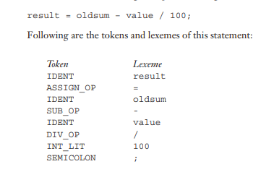
Lexical analyzers extract lexemes from a given input string and produce the corresponding tokens. In the early days of compilers, lexical analyzers often processed an entire source program file and produced a file of tokens and lexemes. Now, however, most lexical analyzers are subprograms that locate the next lexeme in the input, determine its associated token code, and return them to the caller, which is the syntax analyzer. So, each call to the lexical analyzer returns a single lexeme and its token. The only view of the input program seen by the syntax analyzer is the output of the lexical analyzer, one token at a time. The lexical-analysis process includes skipping comments and white space outside lexemes, as they are not relevant to the meaning of the program. Also, the lexical analyzer inserts lexemes for user-defined names into the symbol table, which is used by later phases of the compiler. Finally, lexical analyzers detect syntactic errors in tokens, such as ill-formed floating-point literals, and report such errors to the user.
There are three approaches to building a lexical analyzer:
1. Write a formal description of the token patterns of the language using a descriptive language related to regular expressions.These descriptions are used as input to a software tool that automatically generates a lexical analyzer. There are many such tools available for this. The oldest of these, named lex, is commonly included as part of UNIX systems.
2. Design a state transition diagram that describes the token patterns of the language and write a program that implements the diagram.
3. Design a state transition diagram that describes the token patterns of the language and hand-construct a table-driven implementation of the state diagram. A state transition diagram, or just state diagram, is a directed graph. The nodes of a state diagram are labeled with state names. The arcs are labeled with the input characters that cause the transitions among the states. An arc may also include actions the lexical analyzer must perform when the transition is taken.
State diagrams of the form used for lexical analyzers are representations of a class of mathematical machines called finite automata. Finite automata can be designed to recognize members of a class of languages called regular languages. Regular grammars are generative devices for regular languages. The tokens of a programming language are a regular language, and a lexical analyzer is a finite automaton.
Consider building a compact state diagram for the design of a lexical analyzer.
If we define a character class named DIGIT for digits and uses a single transition on any character in this character class to a state that collects integer literals. We define a character class named LETTER for all 52 letters and use a single transition on the first letter of any name.
Next, we define some utility subprograms for the common tasks inside the lexical analyzer. First, we need a subprogram, which we can name getChar, that has several duties. When called, getChar gets the next character of input from the input program and puts it in the global variable nextChar. getChar must also determine the character class of the input character and put it in the global variable charClass. The lexeme being built by the lexical analyzer, which could be implemented as a character string or an array, will be named lexeme. We implement the process of putting the character in nextChar into the string array lexeme in a subprogram named addChar. This subprogram must be explicitly called because programs include some characters that need not be put in lexeme, for example the white-space characters between lexemes. In a more realistic lexical analyzer, comments also would not be placed in lexeme. When the lexical analyzer is called, it is convenient if the next character of input is the first character of the next lexeme. Because of this, a function named getNonBlank is used to skip white space every time the analyzer is called. Finally, a subprogram named lookup is needed to compute the token code for the single-character tokens. In our example, these are parentheses and the arithmetic operators. Token codes are numbers arbitrarily assigned to tokens by the compiler writer. The state diagram in Figure 7.1 describes the patterns for our tokens. It includes the actions required on each transition of the state diagram.

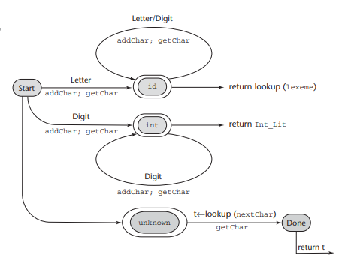
Figure 7.1 A state diagram to recognize names, parentheses, and arithmetic operators

